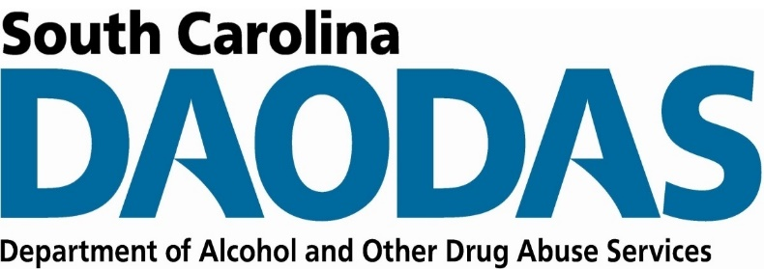
Division of Prevention and Intervention Services
SC DAODAS | 1801 Main Street, 4th Floor, Columbia SC 29201

FY 2022 Prevention SOR 2 Year-End Report
ABC Behavioral Health Center Final Report, October 1, 2021 to September 16, 2022

Strategy Implementation
Instructions: In the table below, please list each Prevention SOR 2 strategy implemented throughout the grant period, October 1, 2021 to September 16, 2022. Also identify the population of focus and total number of people reached per strategy. Insert only the “Strategies” and “Specific Strategy Types” that DAODAS has provided.

Strategy | Specific Strategy Type Implemented | Population | Total Number People Reached

Goals and Objectives
Instructions: Please list each goal and objective. Also indicate the rate, percentage, or number of change per objective to indicate the final outcome or extent to which goals and objectives were achieved.

Goal: To decrease prescription drug overdoses in ABC County.
Goal Outcome: [Insert a statement of goal outcome here.]

Objective | Objective Outcome  (Quantify and describe the extent to which objective met.)

Project Narrative

Accomplishments
Instructions: Please share the greatest accomplishments the organization experienced overall.

Challenges
Instructions: Please share the greatest challenges or barriers the organization experienced overall. Indicate how the organization addressed each challenge or barrier.

Additional Comments
Instructions: Please share any additional feedback the organization would like to express.

